EXPERIMENT 07
PERFORM WEB APPLICATION RECONNAISSANCE USING VARIOUS TOOLS

1. AIM
To gather structural, technical, and parameter information from a web application using Burp Suite Proxy, Developer Tools, and fingerprinting tools.

2. THEORY
Web application reconnaissance analyzes application-layer logic, client-side scripts, form input parameters, and cookie flags (HttpOnly, Secure) to map the application attack surface.

3. TOOLS REQUIRED
- Burp Suite Community Edition
- Firefox Developer Tools
- WhatWeb
- Target (DVWA / Juice Shop)

4. PROCEDURE & COMMANDS
Step 1: Identify Application Frameworks & Technologies
Run WhatWeb against the web application path:
whatweb http://<target-ip>/dvwa

Step 2: Configure Burp Suite Intercepting Proxy
Set browser manual proxy to 127.0.0.1:8080 and enable Burp Proxy interception to record all HTTP traffic.
Step 3: Map Parameters & Hidden Form Fields
Browse through application pages while recording requests in Burp HTTP History. Inspect hidden form inputs (<input type="hidden">) and URL parameters.
Step 4: Inspect Cookie Security Attributes
Examine response Set-Cookie headers in Burp to check for missing HttpOnly and Secure flags:
Set-Cookie: PHPSESSID=abc123xyz; path=/

Step 5: Inspect Client-Side JavaScript Source Files
Open Browser Developer Tools -> Sources tab, search loaded .js files for hardcoded API keys, secrets, or unlinked API endpoints.

5. LAB OBSERVATIONS & OUTPUT SCREENSHOTS
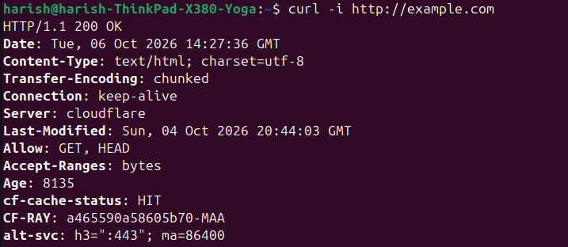

6. EXPECTED OUTPUT RESULT
An application recon matrix detailing identified frontend/backend technologies, form parameter mappings, cookie security flag statuses, and client-side code findings.

7. VIVA VOICE QUESTIONS & ANSWERS
S.NO & VIVA QUESTION | TECHNICAL ANSWER
Q1. How is web application reconnaissance different from web server reconnaissance? | Web server recon focuses on OS and server binary versions. Web app recon focuses on application logic, input forms, cookies, and JS scripts.
Q2. What is the role of Burp Suite's Proxy tab in this experiment? | It intercepts and logs raw HTTP/HTTPS traffic between browser and server, allowing real-time inspection and modification.
Q3. What does the HttpOnly cookie flag protect against? | It blocks client-side scripts from reading the cookie via document.cookie, mitigating XSS-based cookie theft.
Q4. Why would a JavaScript file be a useful place to look during recon? | JS files often contain hardcoded API keys, developer comments, and unlinked backend API endpoints.
Q5. Give an example of how a verbose error message can help an attacker. | A raw SQL stack trace reveals the database engine type, table names, and query structure needed for SQL injection.

